sALT N PEPPER - Platter Menu
48 hours’ notice required for all platters

Slider Platter – with tender beef, lettuce, tomato,
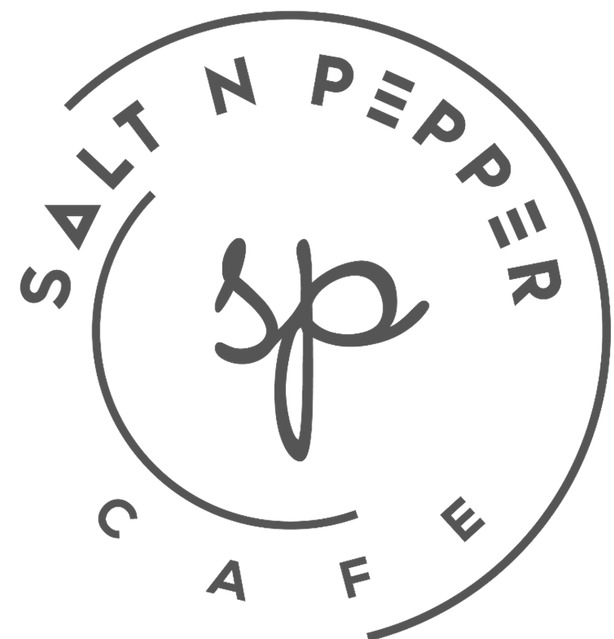
cheese, beetroot chutney
$60

Bali style chicken skewers – with house made
peanut dressing (GF, DF)
$65

Lamb Koftas – with mint yoghurt glaze,
truffle oil, aged balsamic
$60

Mini bruschetta - tomato, basil, garlic, Feta,
extra virgin olive oil, balsamic dressing
$55

Antipasto – Dips, feta, chorizo, olives,
continental meats, crusty bread
$55

Petite King Prawn pineapple Malibu cocktails - baby cos, topped with thousand island dressing (GF)
$60

Crispy chicken wings – with chilli, coriander
& chipotle mayo (GF, DF)
$55

Pizza Platter – 3 pizzas
selection from the current menu
$55

